Daire O’Neill IT2

OPERATING SYSTEMS Assignment one

**Table of Contents:**

Question 1: p1

Question 2: p1-2

Question 3: p2-5

Question 4: p6

Question 5: p6

1a.

An operating system manages the sharing of resources, protection, and communication for a device. It also provides a clean, easy to use abstractions of physical resources.

1b.

Five modules that should be part of an operating system are:

Processes, a process is one instance of a program in execution. At any instance, multiple processes can be running copies of the same program eg. chrome, spotify.

Memory, operating systems allocate memory for programs and decides how much memory to assign each process.

I/O, operating systems are responsible for controlling external devices eg. External hard-drive, mouse. OS defines an interface for each class of devices

Secondary Storage, operating systems are responsive for low level disk functions like read/write blocks. It’s also usually independent of file system, although there might be some cooperation.

File System, secondary storage devices are too crude to use directly for long-term storage. The file system provides a much higher level, more convenient abstraction for persistent storage.

1c.

Process, allows you to execute processes like set up directories, create text files etc.

Memory, allows you to allocate a certain amount of storage for the process you just executed so I can be access faster eg. Accessing a file in another directory you just created.

I/0, allows you to control certain devices eg, accessing and storing a file on an external hard dive.

Secondary Storage, allows you to modify things from your storage eg. Read and write.

File System, allows you to access thing from your storage eg. Directories and files.

2.

Five operating systems are: IOS, IPADOS, MACOS, WATCHOS and windows.

2a.

IOS is designed to run specifically on IPhones by Apple.

IPADOS is designed to run specifically on IPads by Apple

MACOS is designed to run specifically on Desktops and laptops by Apple

WATCHOS is designed to run specifically on Apple Watches by Apple

Windows is designed to run on any from of PC that meets the necessary requirements.

2b.

IOS does support multiple users

IPADOS does support multiple users

MACOS does support multiple users

WATCHOS does support multiple users

Windows does support multiple users

2c.

All of these would be a single user predominant use case

2d.

All of these allow multicurrent activities

3a.

Layered Approach: Windows NT

Simple Structure: MS-DOS

Modules: Linux kernel

Traditional UNIX: Debian

Microkernels: QNX

3b.

**Layered Approach**

Advantage: Simple to debug

Disadvantage: Its less efficient

**Simple Structure**

Advantage: Simple to debug

Disadvantage: Lacks depth in layers

**Modules**

Advantage: Has higher infrastructure uptime levels

Disadvantage: More difficult to code in

**Traditional Unix**

Advantage: Very efficient

Disadvantage: not user friendly

**Microkernels**

Advantage: Minimalistic

Disadvantage: lacks depth

**Diagrams:**

Layered approach

Simple structure

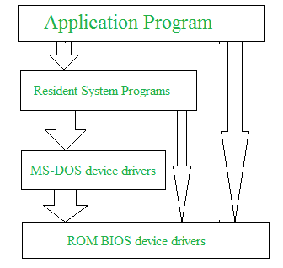

Modules

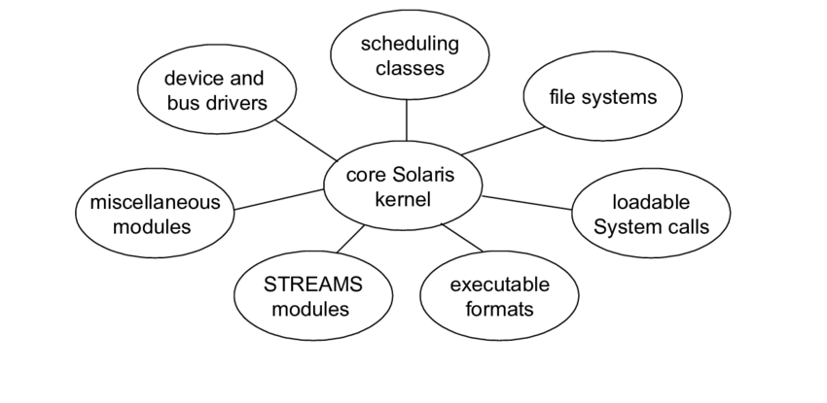

Traditional Unix

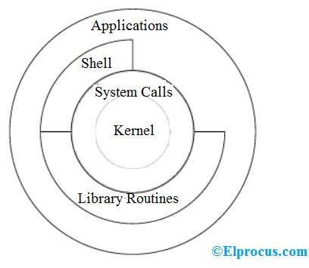

Microkernels

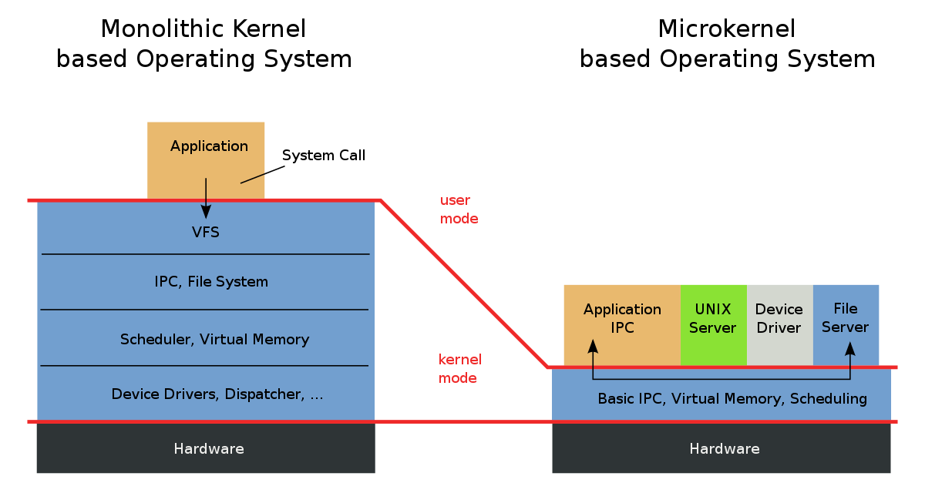

4a.

An interrupt is an action taken that changes the order a processor executes.

4b.

Two ways to determine where an interrupt came from are hardware and software. The CPU will receive an interrupt from eg a keystroke for hardware or writing data to a disk for software.

4c.

DMA is direct memory access, it relates to interrupts by being another form of interruption without affecting the CPU, it can be started in the middle of an instruction execution.

4d.

Three things that could cause an operating system to run are checking for an update (synchronous). Getting a call from an application eg skype (asynchronous) and receiving an email (asynchronous)

5c.

Cache is when the operating system temporarily saves information in memory or to a storage device

5d.

Cache is needed because it improves efficiency.

5e.

Cache management policy is deciding what part of eg. A query should be stored to be accessed again quickly, or if the cache is full what parts to delete in order to save the new information, if any.

5f.

Memory cache

Processor cache